Question 1:

Object:
Create a GitHub account (if you don’t already have one) and update your profile by adding your full name, a short bio, and a professional profile picture.

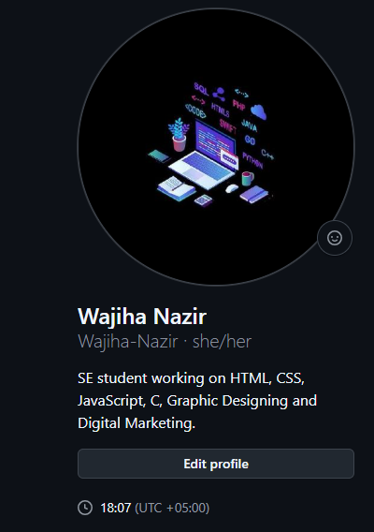

Question 2:

Object:
Create a new repository named PF-Lab03-[YourRollNumber]. Add a README.md file describing yourself and your programming interests.

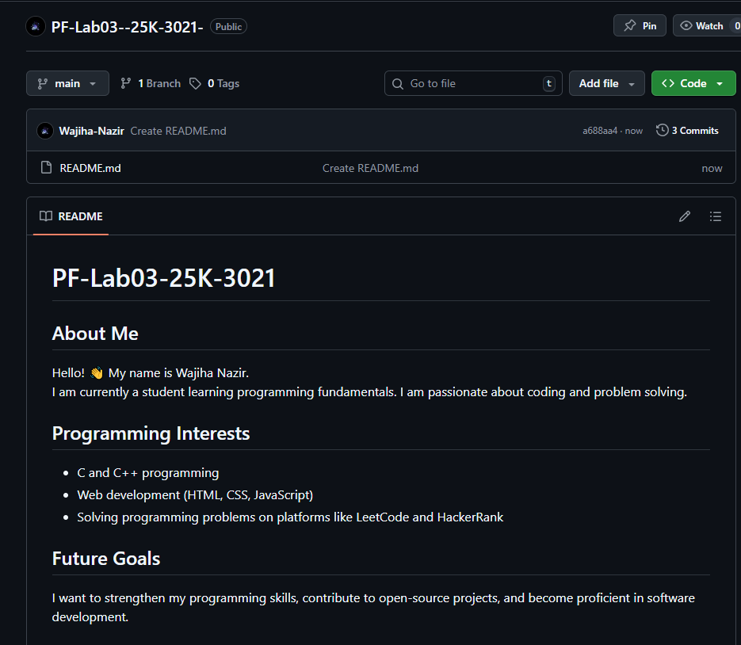

Question 3:

Object:
Create a new branch in your repository named lab03-branch. Inside it, create a file named aboutme.md containing your name, degree program, and one hobby. Commit the file.

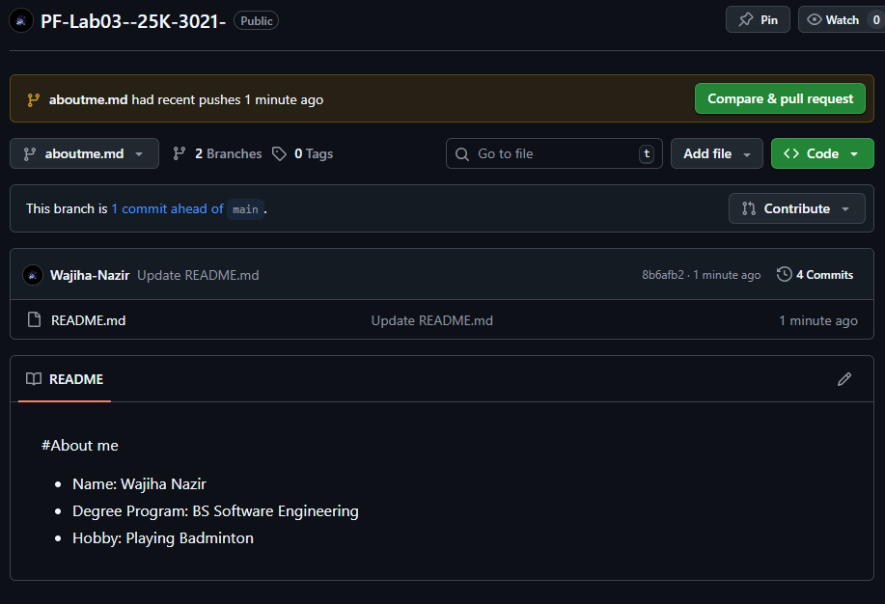

Question 4:

Object:
Raise a pull request to merge your lab03-branch into the main branch. Successfully merge and delete the branch after merging.

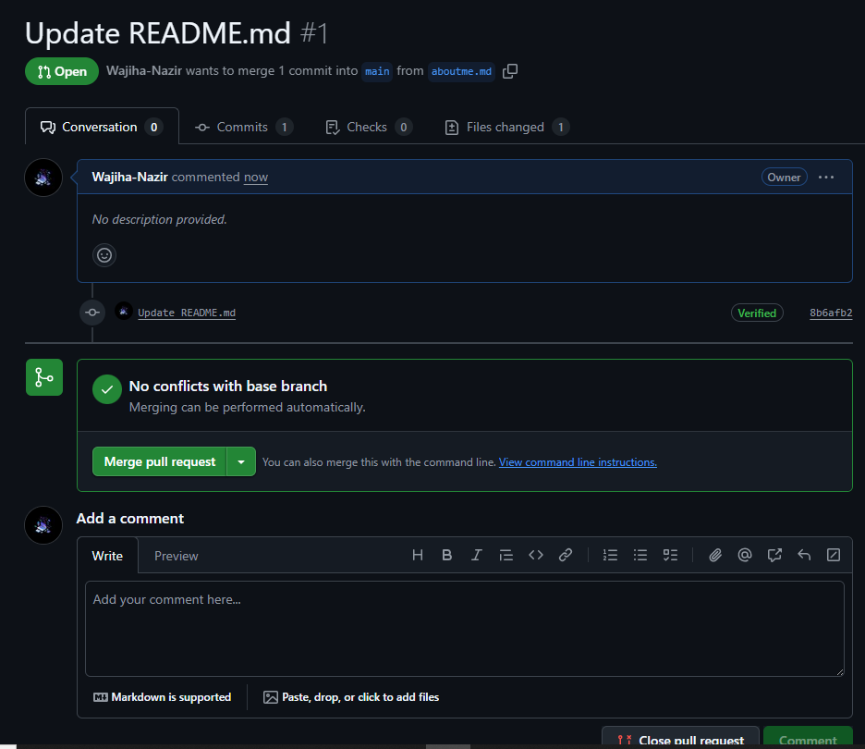
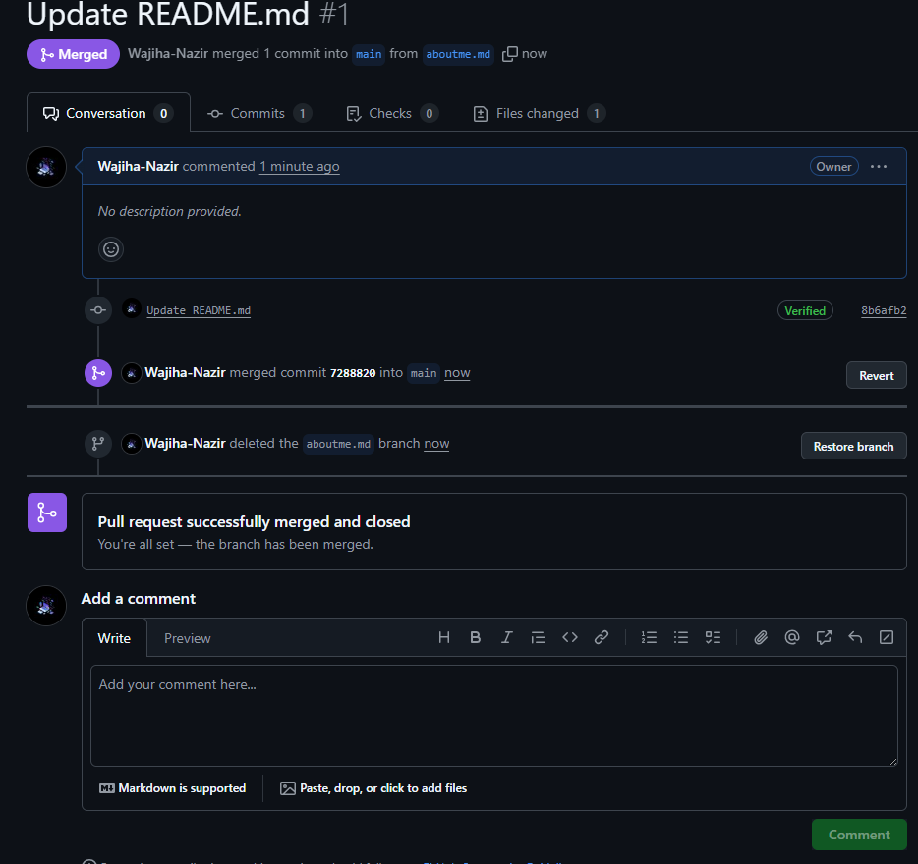

Question 5:

Object:
Edit your README.md to include at least:
● One heading
● One ordered list
● One unordered list
● One bold + italic statement
Commit the changes.

